**Mini Project - Car Showroom Management – Front End**

**Name:** Badri MSV **Roll No:** 195002017

**Name:** Dinesh B **Roll No:** 195002031

**Class:** IT – A

**Subject:** UIT1312 - Database Management Systems and Applications Laboratory

**Front End: Visual Basic for Applications**

**User Forms:**

1. Main Menu

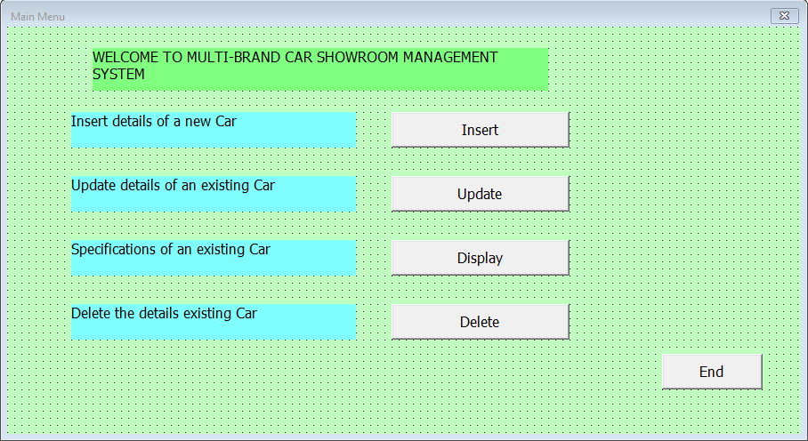

2. Insertion Form

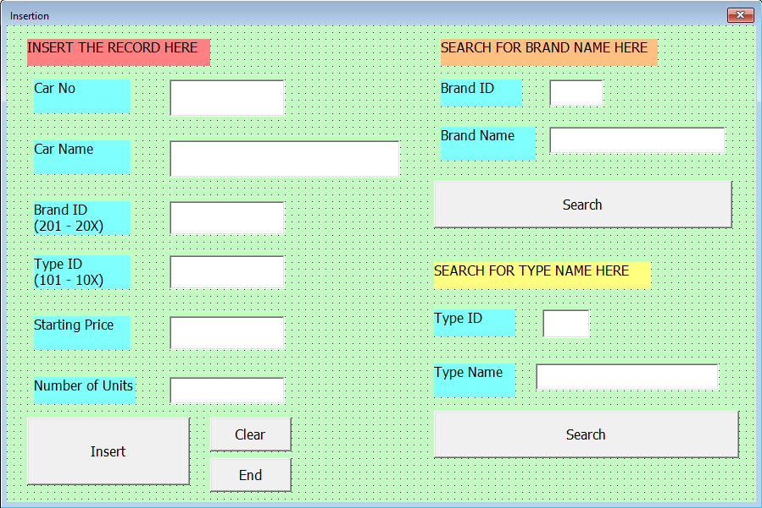

3. Display Form

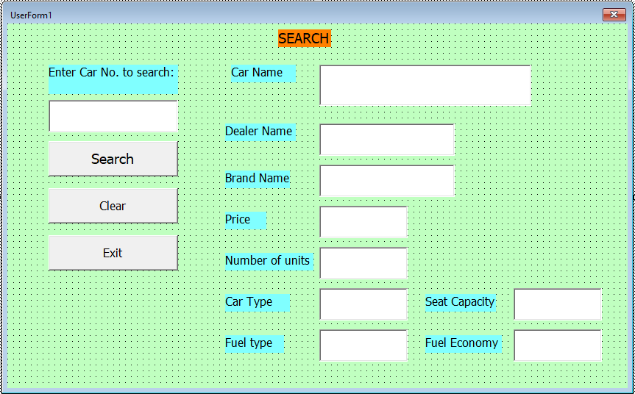

4. Update Form

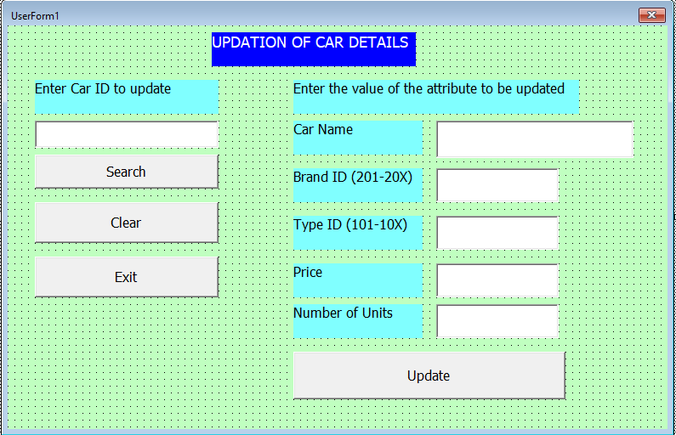

5. Deletion Form

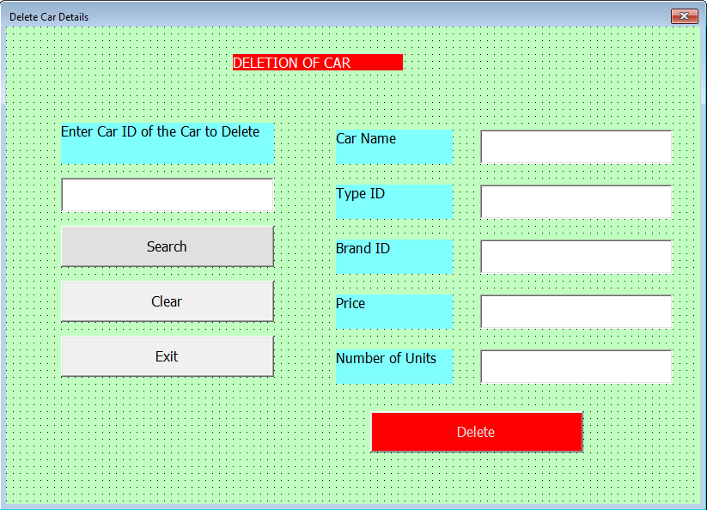

**Visual Basic Code:**

1. Main Menu:

Private Sub CommandButton5_Click()

Unload MenuForm1

End Sub

Private Sub DeleteButton4_Click()

DeletionForm1.Show

End Sub

Private Sub DisplayButton3_Click()

SelectForm1.Show

End Sub

Private Sub InsertButton1_Click()

InsertForm1.Show

End Sub

Private Sub UpdateButton2_Click()

UpdationForm1.Show

End Sub

Private Sub UserForm_Click()

End Sub

2. Insertion Form:

Private Sub CommandButton1_Click()

Set db = New ADODB.connection

Set rs = New ADODB.Recordset

db.Open ("Provider = oraOLEDB.Oracle;User ID = hr;Password = kamas")

rs.Open "select * from details where cno = " & TextBox1.Text & " ", db

If rs.EOF Then

db.Execute "insert into details values(" & TextBox1.Text & ",'" & TextBox2.Text & "'," & TextBox3.Text & "," & TextBox4.Text & "," & TextBox5.Text & "," & TextBox6.Text & ")"

MsgBox "Record Inserted"

Else

MsgBox "Given Car Number already exits."

End If

End Sub

Private Sub CommandButton2_Click()

Set db = New ADODB.connection

Set rs = New ADODB.Recordset

db.Open ("Provider = oraOLEDB.Oracle;User ID = hr;Password = kamas")

rs.Open "select brandname from brand where brandid = " & TextBox7.Text & " ", db

If Not rs.EOF Then

TextBox8.Text = rs("brandname")

Else

MsgBox "No Brand Name exists for the given Brand ID."

End If

End Sub

Private Sub CommandButton3_Click()

Set db = New ADODB.connection

Set rs = New ADODB.Recordset

db.Open ("Provider = oraOLEDB.Oracle;User ID = hr;Password = kamas")

rs.Open "select typename from cartype where typeid = " & TextBox9.Text & " ", db

If Not rs.EOF Then

TextBox10.Text = rs("typename")

Else

MsgBox "No such Car Type exists for the given Type ID."

End If

End Sub

Private Sub CommandButton4_Click()

TextBox1.Text = ""

TextBox2.Text = ""

TextBox3.Text = ""

TextBox4.Text = ""

TextBox5.Text = ""

TextBox6.Text = ""

TextBox7.Text = ""

TextBox8.Text = ""

TextBox9.Text = ""

TextBox10.Text = ""

End Sub

Private Sub CommandButton5_Click()

Unload InsertForm1

End Sub

Private Sub UserForm_Click()

End Sub

3. Display Form:

Dim db As ADODB.connection

Dim rs As ADODB.Recordset

Private Sub CommandButton1_Click()

TextBox1.Text = ""

TextBox2.Text = ""

TextBox3.Text = ""

TextBox4.Text = ""

TextBox5.Text = ""

TextBox6.Text = ""

TextBox7.Text = ""

TextBox8.Text = ""

TextBox9.Text = ""

TextBox10.Text = ""

End Sub

Private Sub End_prog_Click()

Unload SelectForm1

End Sub

Private Sub Search_Click()

Set db = New ADODB.connection

Set rs = New ADODB.Recordset

db.Open ("Provider = oraOLEDB.Oracle;User ID = hr;Password = kamas")

db.Execute "create view dview(vcno,vcname, vbrandname,vpriceUSD, vnoofunits, vtypename, vfueltype, vfueleconomy, vseatcapacity, vdealername) as select cno,cname, brandname,priceUSD, noofunits, typename, fueltype, fueleconomy, seatcapacity, dealername from details d, cartype t,brand b where d.typeid = t.typeid and d.brandid = b.brandid"

rs.Open "select * from dview where vcno = " & TextBox1.Text & " ", db

If Not rs.EOF Then

TextBox2.Text = rs("vcname")

TextBox3.Text = rs("vbrandname")

TextBox4.Text = rs("vpriceUSD")

TextBox5.Text = rs("vnoofunits")

TextBox6.Text = rs("vtypename")

TextBox7.Text = rs("vfueltype")

TextBox8.Text = rs("vfueleconomy")

TextBox9.Text = rs("vseatcapacity")

TextBox10.Text = rs("vdealername")

Else

MsgBox "No such record found"

End If

db.Execute "drop view dview"

End Sub

Private Sub UserForm_Activate()

End Sub

4. Update Form:

Private Sub CommandButton1_Click()

Set db = New ADODB.connection

Set rs = New ADODB.Recordset

db.Open ("Provider = oraOLEDB.Oracle;User ID = hr;Password = kamas")

db.Execute "update details set cname = '" & TextBox2.Text & "' where cno = " & TextBox1.Text & " "

db.Execute "update details set brandid = " & TextBox3.Text & " where cno = " & TextBox1.Text & " "

db.Execute "update details set typeid = " & TextBox4.Text & " where cno = " & TextBox1.Text & " "

db.Execute "update details set priceUSD = " & TextBox5.Text & " where cno = " & TextBox1.Text & " "

db.Execute "update details set noofunits = " & TextBox6.Text & " where cno = " & TextBox1.Text & " "

MsgBox "Record Updated."

End Sub

Private Sub CommandButton3_Click()

Set db = New ADODB.connection

Set rs = New ADODB.Recordset

db.Open ("Provider = oraOLEDB.Oracle;User ID = hr;Password = kamas")

rs.Open "select * from details where cno = " & TextBox1.Text & " ", db

If Not rs.EOF Then

TextBox2.Text = rs("cname")

TextBox3.Text = rs("brandid")

TextBox4.Text = rs("typeid")

TextBox5.Text = rs("priceUSD")

TextBox6.Text = rs("noofunits")

Else

MsgBox "No such record found"

End If

End Sub

Private Sub CommandButton4_Click()

Unload UpdationForm1

End Sub

Private Sub CommandButton5_Click()

TextBox1.Text = ""

TextBox2.Text = ""

TextBox3.Text = ""

TextBox4.Text = ""

TextBox5.Text = ""

TextBox6.Text = ""

End Sub

Private Sub UserForm_Click()

End Sub

5. Deletion Form:

Private Sub CommandButton1_Click()

Set db = New ADODB.connection

Set rs = New ADODB.Recordset

db.Open ("Provider = oraOLEDB.Oracle;User ID = hr;Password = kamas")

db.Execute "delete from details where cno = " & TextBox1.Text & " "

MsgBox "Record Deleted."

End Sub

Private Sub CommandButton2_Click()

Set db = New ADODB.connection

Set rs = New ADODB.Recordset

db.Open ("Provider = oraOLEDB.Oracle;User ID = hr;Password = kamas")

rs.Open "select * from details where cno = " & TextBox1.Text & " ", db

If Not rs.EOF Then

TextBox2.Text = rs("cname")

TextBox3.Text = rs("brandid")

TextBox4.Text = rs("typeid")

TextBox5.Text = rs("priceUSD")

TextBox6.Text = rs("noofunits")

Else

MsgBox "No such record found"

End If

End Sub

Private Sub CommandButton3_Click()

TextBox1.Text = ""

TextBox2.Text = ""

TextBox3.Text = ""

TextBox4.Text = ""

TextBox5.Text = ""

TextBox6.Text = ""

End Sub

Private Sub CommandButton4_Click()

Unload DeletionForm1

End Sub

Private Sub UserForm_Click()

End Sub

**Program Outputs:**

